Use Cases Description
UC4- Room Management

For

Meeting Room
Booking System
(MRBS)

Prepared by K15T1-Team11
Van Lang University
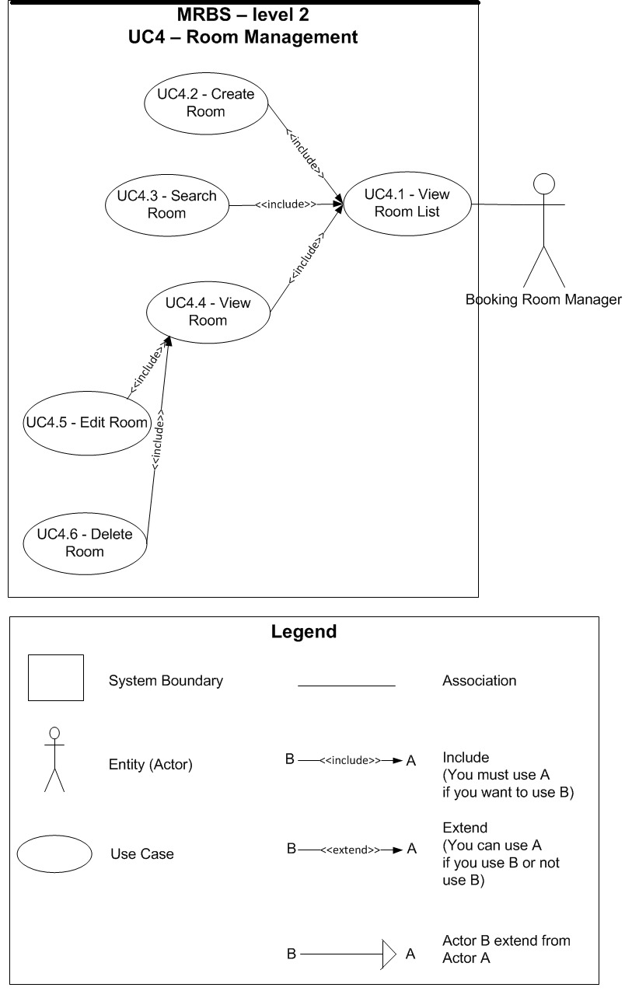
Table of Contents
UC4.1 – View Room List 4
UC4.2 – Create Room 4
UC4.3 – Search Room 5
UC4.4 – View Room 6
UC4.5 – Edit Room 7
UC4.6 – Delete Room 7

UC4.1 – View Room List
ID | UC4.1
Name | View Room List
Author | Tam Do | Modify by
Date | 06/29/12 | Update
Actor | Booking Room Manager
Description | User can view a list of room
Precondition | User signed in system by Booking Room Manager’s account
Post condition: | System shows all room
Main flow: | 1. User press “Danh mục”  2. User choose “Quản lý phòng”  3. System show new dialog “Quản lý phòng”  4. System show a list of room
Alternative flow:
Exception :
Includes:
Priority: | Normal
Business rules:
Mockup screen

UC4.2 – Create Room
ID | UC4.2
Name | Create Room
Author | Tin Nguyen | Modify by | Tam Do
Date | 06/21/12 | Update | 07/06/12
Actor | Booking Room Manager
Description | User can create a new room
Precondition | User signed in system by Booking Room Manager’s account  User staying at “Quản lý phòng” form
Post condition: | System create a new room into database and show announcement
Main flow: | 1. User press “Thêm mới” button  2. System change form to create a new room  3. User fill in the form  4. User press “Lưu” button  5. System check the valid of information (BR4.2.01, BR4.2.02, BR4.2.03)  6. System check the valid of information with existing data in database (BR4.2.04)  7. System save a new room into database  8. System show announcement that “Thêm phòng thành công” with “OK” button
Alternative flow: | After step 3 of main flow:  4. User press “Hủy” button  5. System change form to not create a new room
Alternative flow: | After step 5 of main flow (BR4.2.01):  6. System show announcement that “Các thông tin có (*) không được để trống” with “OK” button
Alternative flow: | After step 5 of main flow (BR4.2.02, BR4.2.03):  6. System show announcement that “Thông tin nhập vào không hợp lệ” with “OK” button
Alternative flow: | After step 6 of main flow (BR4.2.04):  7. System show announcement that “Tên phòng đã tồn tại trong hệ thống, vui lòng thử lại” with “OK” button
Exception :
Includes:
Priority: | Normal
Business rules: | BR4.2.01 – Required field not accept null: “Tên phòng”  BR4.2.02 – “Tên phòng” not accept more than 5 characters and space between them; accept characters and numeric only  BR4.2.03 – “Sức chứa” not accept space between them; accept numeric only  BR4.2.04 – “Tên phòng” not exist in database
Mockup screen

UC4.3 – Search Room
ID | UC4.3
Name | Search Room
Author | Tin Nguyen | Modify by | Tam Do
Date | 06/21/12 | Update | 06/29/12
Actor | Booking Room Manager
Description | User can search room by name or view all room
Precondition | User signed in system by Booking Room Manager’s account  User staying at “Quản lý phòng” form
Post condition: | System show the results
Main flow: | 1. User types the word to search for  2. User press “Enter” from the keyboard  3. System check the valid of information (BR4.3.01)  4. System show the results
Alternative flow: | After step 3 of main flow (BR4.3.01):  4. Nothing appears on list of room
Alternative flow: | After step 4 of main flow:  5. User press “Tất cả” button  6. System show all room on list of room
Exception :
Includes:
Priority: | Normal
Business rules: | BR4.3.01 – “Tìm kiếm phòng” not accept more than 10 characters; accept characters and numeric only
Mockup screen

UC4.4 – View Room
ID | UC4.4
Name | View Room
Author | Tin Nguyen | Modify by | Tam Do
Date | 06/21/12 | Update | 06/29/12
Actor | Booking Room Manager
Description | User can view a detail room information
Precondition | User signed in system by Booking Room Manager’s account  User staying at “Quản lý phòng” form
Post condition: | System show a detail room information that user choose
Main flow: | 1. User choose a room from list of room  2. System show a detail room information that user choose
Alternative flow:
Exception :
Includes:
Priority: | Normal
Business rules:
Mockup screen

UC4.5 – Edit Room
ID | UC4.5
Name | Edit Room
Author | Tin Nguyen | Modify by | Tam Do
Date | 06/21/12 | Update | 07/06/12
Actor | Booking Room Manager
Description | User can edit a room information
Precondition | User signed in system by Booking Room Manager’s account  User staying at “Quản lý phòng” form and viewing a detail room information
Post condition: | System edit a room information in database and show announcement
Main flow: | 1. User edit a room information that accept to edit (BR4.5.01)  2. User press “Lưu” button  3. System check the valid of information (BR4.5.02)  4. System save a room information that edited in database  5. System show announcement that “Chỉnh sửa thông tin thành công” with “OK” button
Alternative flow: | After step 1 of main flow:  2. User press “Hủy” button  3. System restore all information before user edit
Alternative flow: | After step 3 of main flow (BR4.5.02):  4. System show announcement that “Thông tin nhập vào không hợp lệ” with “OK” button
Exception :
Includes:
Priority: | Normal
Business rules:
Mockup screen | Normal
BR4.5.01 – User can edit field: “Sức chứa”
BR4.5.02 – “Sức chứa” not accept space between them; accept numeric only

UC4.6 – Delete Room
ID | UC4.6
Name | Delete Room
Author | Tin Nguyen | Modify by | Tam Do
Date | 06/21/12 | Update | 06/29/12
Actor | Booking Room Manager
Description | User can delete a room information
Precondition | User signed in system by Booking Room Manager’s account  User staying at “Quản lý phòng” form and viewing a detail room information
Post condition: | System delete a room information in database and show announcement
Main flow: | 1. User press “Xóa” button  2. System show announcement that “Bạn có muốn xóa thông tin này khỏi hệ thống không?” with “Yes” and “No” button  3. User press “Yes” button  4. System delete a room information in database (BR4.6.01)
Alternative flow: | After step 2 of main flow:  3. User press “No” button  4. Nothing appears
Exception :
Includes:
Priority: | Normal
Business rules: | BR4.6.01 – Not delete information in database, system just change the status of that information that user choose to delete into “Đã xóa” in database
Mockup screen

